
WELCOME
Welcome to The Crawler’s Day Care.
Where little explorers learn, play, and grow.
ABOUT
Click here to apply
Fee & Payment Policy
Attendance & Punctuality
Nutrition Policy
Health & Wellness Policy
Uniform Policy
Stationery & Toiletry Policy
CONTACTS

⭐ ABOUT US
The Crawler’s Day Care is a warm, safe, and supportive environment where children are encouraged to become confident and independent at their own pace.
We believe that independence starts early, and our daily activities are designed to help children learn important skills such as:
• exploring their surroundings
• learning through play
• communicating their needs
• trying new things on their own
• building confidence and self-trust
Our caregivers guide each child gently, allowing them to grow while still feeling secure and supported. We celebrate every milestone — big or small — and help children discover their abilities in a loving environment.
At The Crawler’s Day Care, we don’t just care for children…
We help them become little independent explorers.

APPLICATION FORM
Please fill out this form to register your child at The Crawler’s Day Care& After Care. Registration is compulsory. All fields marked with * are required. By submitting this form, you agree to all policies
Child’s Information Table
Full Name
Date of Birth
Gender
Home Address *
Allergies / Medical Conditions

Parent/Guardian Information Table
Full Name *
Relationship to Child *
Phone Number *
Email *
Alternative Emergency Contact

Consent & Agreement Section
☐I agree that registration is compulsory and I accept all policies

Fee & Payment Policy
“At The Crawler’s Day Care Center & After Care, we strive to provide quality care and a safe environment for all children. The monthly fees are structured as follows:
- Children who do not wear pampers: R900 per month
- Children who wear pampers: R1000 per month
A registration fee of R400 is required for all new children enrolling at the daycare.
December fees must be paid in advance, by October, to secure your child’s place for the end-of-year activities.
The concert fee and graduation fee are compulsory and non-refundable.
Fees are payable in advance at the beginning of each month. Late payments will incur an additional charge of R100. All payments are to be made via the daycare’s approved payment methods. Parents/guardians are responsible for ensuring that fees are paid on time to secure their child’s place.”
☐ I have read and understood this policy.

Attendance & Punctuality Policy
“At The Crawler’s Day Care Center & After Care, punctuality and regular attendance are important to ensure that every child benefits from our programs and routines. The daycare operates as follows:
- Opening hours: 07:00 in the morning
- Closing hours: 17:00 in the evening
- School gates close at 08:00, even during school holidays.
Parents/guardians are expected to ensure their child arrives on time. If a child is dropped off after 17:00pm, a late arrival charge of R20 will be applied.
Consistent attendance is encouraged to support the child’s learning and social development. Please notify the daycare in advance if your child will be absent for any reason.”
☐ I have read and understood this policy.

Nutrition & Meals Policy
“At The Crawler’s Day Care Center & After Care, we promote healthy eating habits for all children in our care. Parents/guardians are encouraged to provide:
- Fruits for snacks (e.g., apples, bananas)
- Vegetables (e.g., carrots)
- A bottle of water for hydration throughout the day
Unhealthy foods such as sweets, noodles, chips, or other junk food are not allowed in the daycare.
Encouraging nutritious snacks supports your child’s growth, concentration, and overall wellbeing.”
☐I have read and understood this policy.

Health & Illness Policy
At The Crawler’s Day Care & After Care, the health and safety of all children is our top priority. Children who are unwell, showing symptoms of contagious illnesses (such as fever, vomiting, diarrhea, or any infectious condition), must stay at home to prevent the spread of illness to other children.
Parents/guardians are requested to notify the daycare if their child is sick and to follow medical advice before returning to the daycare. This ensures a safe and healthy environment for all children and staff.
Parents/guardians who attempt to bring a sick child to the daycare will be asked to take the child home immediately. Repeated violations may result in temporary suspension of enrollment.
☐ I have read and understood this policy.

Uniform Policy
At The Crawler’s Day Care & After Care, wearing the official school uniform is compulsory for all children. No child will be allowed to attend the daycare without the proper uniform.
The uniform helps create a sense of belonging, equality, and school identity among the children. Parents/guardians are responsible for ensuring their child comes dressed in the complete and correct uniform each day.
UNIFORM LIST
R100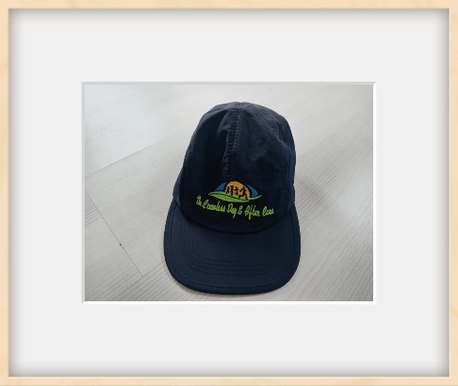 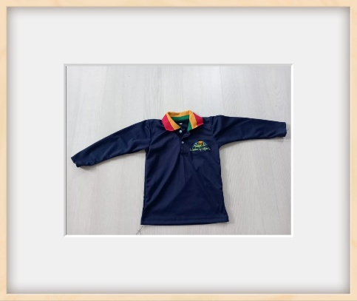 R230
R200 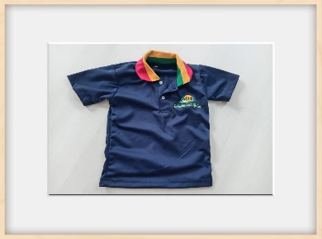  R100

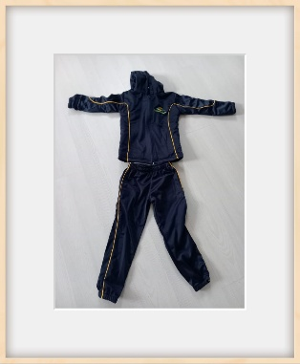 R 500

☐I have read and understood this policy
⭐ Stationery & Toiletry Policy
Stationery & Toiletry Policy
To ensure smooth learning and daily operations, all learners are required to bring the full list of compulsory stationery and toiletry items provided by the school. The list shall be handed per request.

1. Submission Deadline
All required stationery and toiletries must be submitted by the 31st of March each year.

2. Failure to Provide Stationery
If the stationery and toiletry items are not provided by the due date, the parent/guardian will be required to pay a Stationery & Toiletry Fee of R1500.

3. Non-Refundable Fee
The R1500 fee charged for stationery and toiletries is strictly non-refundable, as it immediately goes toward purchasing essential items needed for the child’s daily use.

4. Purpose of This Policy
This policy ensures that:
- Every child has the necessary materials for learning.
- The school can operate smoothly without delays caused by missing supplies.
- Teachers have consistent resources for all students.

⭐ Tick-Box Section

☐ I understand that stationery and toiletries are compulsory.
☐I agree to submit all required items by 31 March.
☐I understand that if I fail to submit the items, I will be required to pay the non-refundable R1500 fee.
☐ I understand that this fee covers the cost of stationery and toiletries for my child.
CONTACTS
WhatsApp: +27 784741595/ +27 762624012

